Ideation Phase
Empathize & Discover

Date | 28 November 2025
Name | Santhosh G
Team ID
Project Name | Book Store App
Maximum Marks | 4 Marks

Empathy Map Canvas:

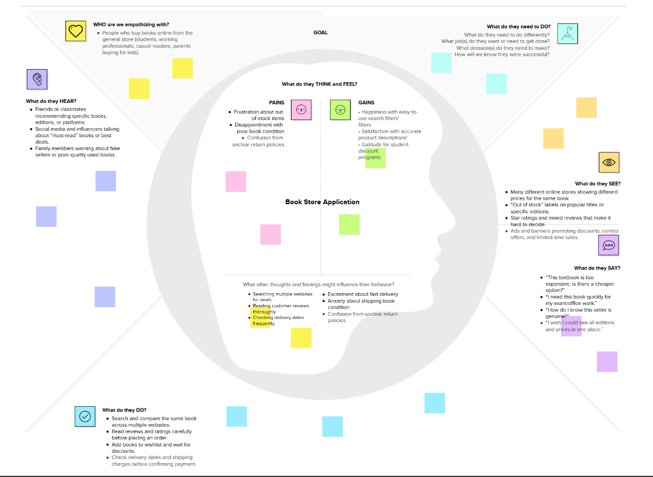

Who are we empathizing with?
- People who buy books online from the general store (students, working professionals, casual readers, parents buying for kids).
What do they HEAR?
- Friends or classmates recommending specific books, editions, or platforms.
- Social media and influencers talking about “must-read” books or best deals.
- Family members warning about fake sellers or poor-quality used books.
What do they SEE?
- Many different online stores showing different prices for the same book.
- “Out of stock” labels on popular titles or specific editions.
- Star ratings and mixed reviews that make it hard to decide.
- Ads and banners promoting discounts, combo offers, and limited-time sales.
What do they SAY?
- “This textbook is too expensive; is there a cheaper option?”
- “I need this book quickly for my exam/office work.”
- “How do I know this seller is genuine?”
- “I wish I could see all editions and prices in one place.”
What do they DO?
- Search and compare the same book across multiple websites.
- Read reviews and ratings carefully before placing an order.
- Add books to Wishlist and wait for discounts.
- Check delivery dates and shipping charges before confirming payment.
What do they FEEL? (optional but useful)
- Excited about finding the right book at a good price.
- Anxious about late delivery or receiving the wrong/poor-quality book.
- Confused by too many choices and unclear return policies.
What do they NEED TO DO?
- Quickly find the correct book (right title, author, edition, language) without confusion.
- Confidently choose a trusted seller based on clear ratings and policies.
- Place an order with transparent price, delivery date, and easy return options.
- Track their order status and receive the book in good condition on time.

